Game Design Document For

**MY ZOO VR**

A WILD EXPERIENCE

Version 1.0

2018

Table of Content

**GAME OVERVIEW** 4

HIGH CONCEPT 4

PHYLOSOPHY 4

HOW IS IT POSSIBLE? 4

FEEL THE ADRENALINE 4

THE INTRIGUE 5

**COMMON QUESTIONS** 5

WHAT IS MY ZOO VR? 5

WHAT DO I CONTROL/ WHO AM I? 5

WHAT IS THE PREMISE/STORY? 5

WHERE DOES THE GAME TAKE PLACE? 6

WHAT ARE THE GOALS/OBJECTIVES OF THE GAME? 6

WHAT IS THE MAIN FOCUS? 6

WHAT’S DIFFERENT? 6

WHAT IS VIRTUAL REALITY? 6

**FEATURE HIGHLIGHTS** 7

ADVANCE BETWEEN FENCES 7

DISPLACEMENT IN ANY ADDRESS 7

INFORMATION ABOUT ANIMALS. 7

REPRODUCTION OF AUDIOS 7

VIEW IN PERSPECTIVE. 8

**CONTROL OVERVIEW** 8

VIRTUAL REALITY GLASSES 8

**ACCES BUTTON** 8

**CIRCLE POINTER** 9

**FEATURE DETAILS** 9

WALK THE ZOO: 9

ACTIVATE SIGNALS: 9

LOOK AND LISTEN TO ANIMALS. 10

**GAME CHARACTERS** 10

MAIN CHARACTER 10

**THE USER:** 10

NPC CHARACTERS 11

**The Rhinoceros** 11

**The Elephant:** 11

**The Zebra:** 12

**The deer:** 12

**The Wolves: The Wolf (Canislupus):** 13

**The Lions:** 14

**The Crocodiles:** 15

**The Hippos:** 15

**Fish:** 16

**Birds:** 17

**Farm Animals:** 17

**MUSICAL SCORES AND SOUND EFFECTS** 18

MUSIC AND SOUNDS USED: 18

**GAME INTERFACE:** 19

SCREEN FLOW DIAGRAM: 19

# GAME OVERVIEW

## HIGH CONCEPT

**“A WILD EXPERIENCE”**

My Zoo VR is a trip in virtual reality where the user moves on a path through cages full of wild animals and others not so wild. The user has control of the automobile in which it is transported and of the camera that is in the car, and that allows him to have a better view of the animals of the zoo. To advance, the user must select the arrow corresponding to the place where he wants to go, these arrows will appear along the route as the user advances. In the same way, each cage contains signals that can be seen by the user and can be selected to obtain information about the animal that is there.

## PHYLOSOPHY

## HOW IS IT POSSIBLE?

The goal is to have the user say "How is that possible?" at the time of putting on the virtual reality glasses for the first time. I want the user to feel inside a zoo, surrounded by many wild animals and able to move through it in any direction. The tour contains audios and images with information corresponding to each animal, which make the experience more striking.

## FEEL THE ADRENALINE

I want the user to see and feel the adrenaline of having the animals close to him and listening to the sounds they reproduce. The more the user advances, the more visual feedback they will have and the more adrenaline, they will generate the sensation of being surrounded by wild animals.

## THE INTRIGUE

I will make the user to move forward to ask, "What will be the next animal?", and in the end you will have a surprise that you did not expect, like farm animals and an aquarium with sharks and goldfish.

# COMMON QUESTIONS

## WHAT IS MY ZOO VR?

My ZOO VR is a virtual reality tour through a zoo full of animals found in fences and found throughout the zoo.The user has control of a car with which he can move and a camera with which he can observe both animals and what happens in their environments and listen to the sounds they reproduce. In addition, the user will find on each fence, several signs with information about the animal that is there.

## WHAT DO I CONTROL/ WHO AM I?

The user controls a car with which he moves through the zoo and from which he can observe what is happening around him. The user has a perspective view that is in the car and thanks to which you can appreciate the animals.

## WHAT IS THE PREMISE/STORY?

The user is a tourist who travels in a car while watching, listening and learning about the animals that the zoo contains.

## WHERE DOES THE GAME TAKE PLACE?

The tour takes place in a zoo surrounded by trees and that contains inside fences with some animals inside that the user can see, hear and learn about them.

## WHAT ARE THE GOALS/OBJECTIVES OF THE GAME?

The objective of the tour is for the user to visit all the fences available at the zoo while he / she knows and learns about the animals it contains.

## WHAT IS THE MAIN FOCUS?

The main focus of the tour is to visit the zoo and observe both the animals and the information about them.

## WHAT’S DIFFERENT?

What makes My ZOO VR different in comparison to other virtual reality tours is that it is developed in a zoo and the user has the possibility to see and hear animals that are not commonly seen in society.

WHAT IS VIRTUAL REALITY?  
Virtual reality is an environment of scenes or objects of real appearance generated by computer technology, which creates in the user the sensation of being immersed in it. This environment is contemplated by the user through a device known as virtual reality glasses or helmet.

# FEATURE HIGHLIGHTS

The following is a list of the game's features listed in order of priority. The section below gives more details for each feature.

## ADVANCE BETWEEN FENCES

The user will advance along the path and while he is doing it, he will have a fence on his right and on the left another fence with a different animal.

## DISPLACEMENT IN ANY ADDRESS

The user can make the trip in any direction to make sure it passes through all the fences and observe all the animals.

This can be done thanks to the direction arrows that will appear as the user advances in the course.

## INFORMATION ABOUT ANIMALS.

The user will find information related to the animals of the zoo, this information is found in some signs that are distributed by the zoo in each fence. When the user selects one of the signals containing information, this information will be expanded and can be seen by the user.

## REPRODUCTION OF AUDIOS

As the user advances between the fences, the animals will reproduce the audio corresponding to the sound they generate.

## VIEW IN PERSPECTIVE.

The user has a perspective view, which improves the visual experience, this view is located on the car that transports the user, giving a greater range of vision.

# CONTROL OVERVIEW

## VIRTUAL REALITY GLASSES

**ACCES BUTTON**: Thanks to this button, the user can interact with the directional arrows that allow him to move and the signals that contain the information of the animals.  
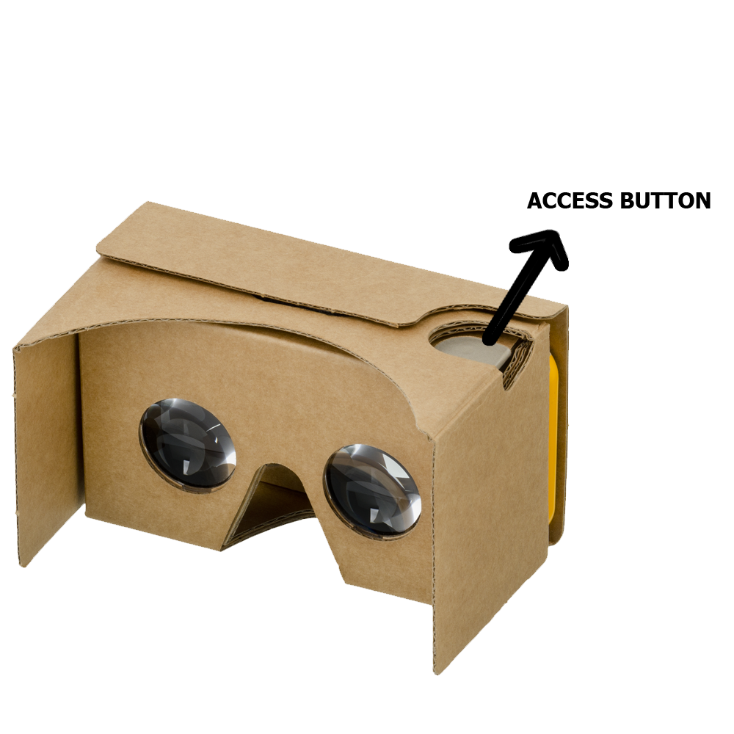

**CIRCLE POINTER**: It can only be seen by the user through virtual reality glasses. Thanks to this you can interact with the different elements of the route, by touching the access button.



# FEATURE DETAILS

The following are the fine details of all the features in the game, listed in order of priority.

## WALK THE ZOO:

The main action of the user is to advance along the path of the zoo, this thanks to the arrows of direction.

## ACTIVATE SIGNALS:

When the user selects a signal in one of the fences that contain animals, this signal shows the information related to the animal that is there.

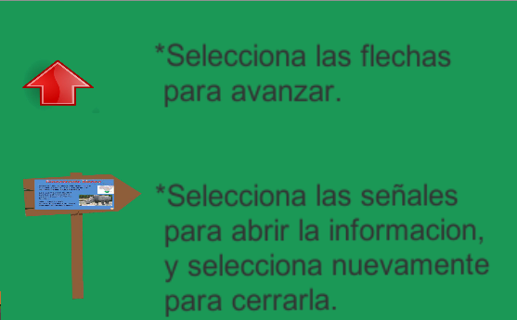

## LOOK AND LISTEN TO ANIMALS.

Each time the user goes through a fence, he can see and hear the animal inside.

# GAME CHARACTERS

## MAIN CHARACTER

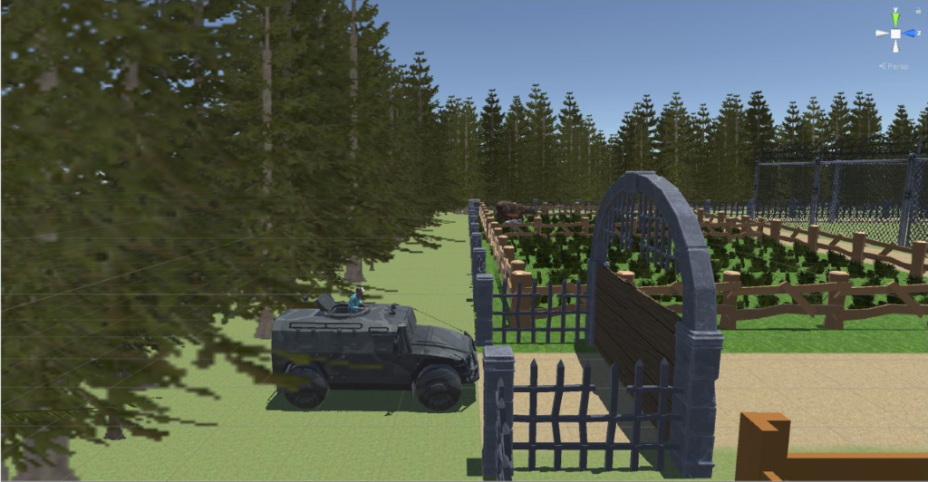**THE USER:** He is in charge of directing the car on which the camera is located through which you can see where the car is moving and what is around it.

## NPC CHARACTERS

The NPC characters are wild animals, farm animals, birds and fish.

**The Rhinoceros**: Rhinocerotids (Rhinocerotidae, from the Greek ρινός (rinós), "nose" and κερος (keros), "horn"), known as rhinos, are a family of placental mammals of the ceratomorphic suborder belonging to the order of perisodáctilos.

There are currently five species: the white rhinoceros and the black rhinoceros in Africa; and the rhinoceros of Java, rhinoceros of India and rhinoceros of Sumatra in Asia. According to the conservation status classification compiled by the International Union for the Conservation of Nature, the rhino species of Java, Sumatra and black are in "critical danger" '; that of India is in "danger", and the target is considered "vulnerable".

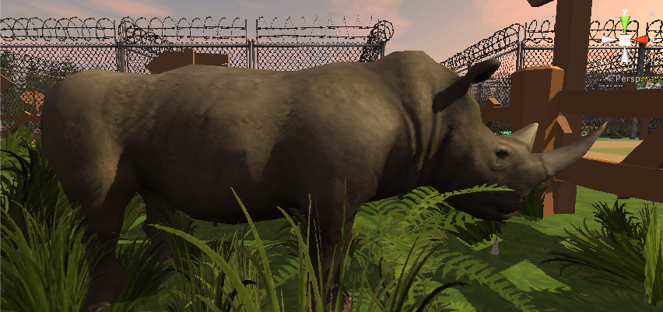

**The Elephant:** Elephants are the largest terrestrial animals that exist today. The gestation period is 22 months, the longest in any terrestrial animal. Birth weight is usually 120 kg. Normally they live from 50 to 70 years, but ancient records document maximum ages of 82. The largest elephant that has been hunted, of which there is record, weighed around 11 000 kg (Angola, 1956) reaching a height on the cross 3.96 m, one meter higher than the average African elephant. The smallest elephant, about the size of a young or large pig, is a prehistoric species that existed on the island of Crete, Elephas creticus, during the Pleistocene.

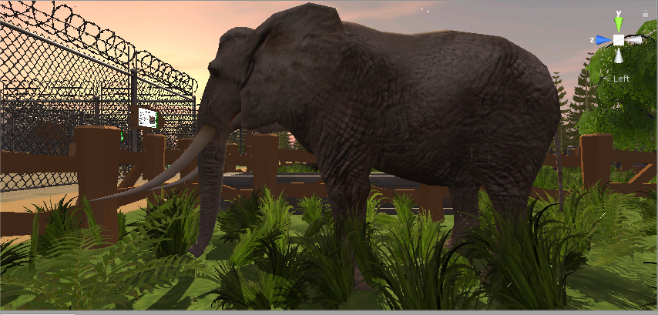

**The Zebra:** They are known as zebra (or zebra, spelling in disuse) to three species of the Equus genus of Africa Equus grevyi (Grevy's zebra), Equus quagga (common zebra) and Equus zebra (mountain zebra) whose most distinctive feature It is its color based on black and white stripes. To the same genus that also belong horses and donkeys.

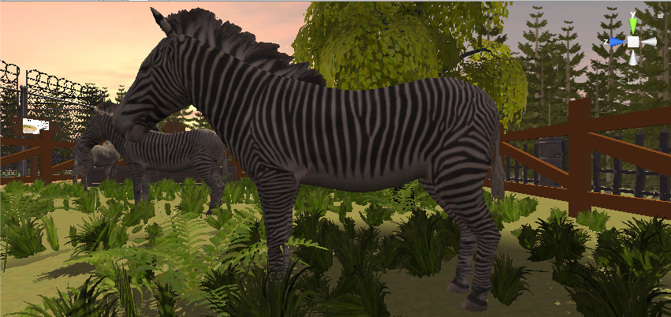

**The deer:** The common deer (Cervus elaphus), also called European deer, red deer, red deer or deer, is a species of deer widely distributed in the northern hemisphere. Some twenty-seven different subspecies have been documented with a distribution area that extends from the Maghreb, the Iberian Peninsula and Great Britain to a large part of North America, which differ from each other by the size, length and color of the hair and shape of the hair. the horns The six subspecies of North American oysters, formerly classified in the species Cervus canadensis, are currently classified as subspecies of Cervus elaphus. The deer reach puberty a year after birth. It is included in the list 100 of the most harmful invasive alien species in the world5 of the International Union for the Conservation of Nature.

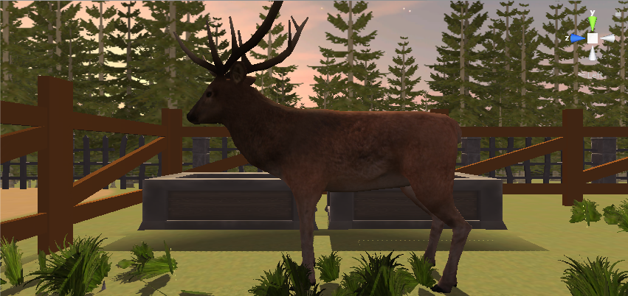

**The Wolves: The Wolf (Canislupus):** It is a species of placental mammal of the order of carnivores. The domestic dog (Canis lupus familiaris) is considered a member of the same species according to different indications, the DNA sequence and other genetic studies. The wolves were once abundant and were distributed throughout North America, Eurasia and the Middle East. Currently, for a number of reasons related to man, including the widespread habit of hunting, wolves inhabit only a very limited portion of what was once their territory.

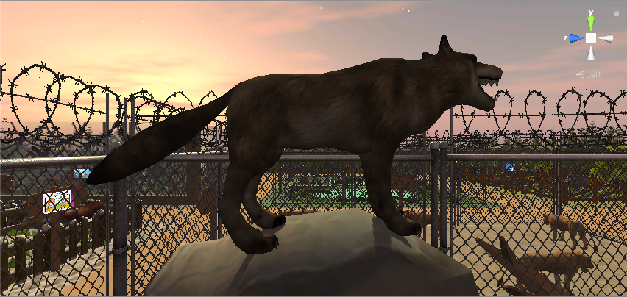

**The Lions:** The lion (Panthera leo) is a carnivorous mammal of the family of the felidae and one of the five species of the genus Panthera. Wild lions live in increasingly scattered and fragmented populations of sub-Saharan Africa (except for the jungle regions of the Atlantic coast and the Congo Basin) and a small area of north-western India (a population in critical danger in the Park). National Forest of Gir and surroundings), having disappeared from the rest of South Asia, Western Asia, North Africa and the Balkan peninsula in historical times. Until the end of the Pleistocene, about 10,000 years ago, of the great terrestrial mammals, the lion was the most widespread after humans. Its distribution covered most of Africa, much of Eurasia, from western Europe to India, and in America, from the Yukon River to southern Mexico.

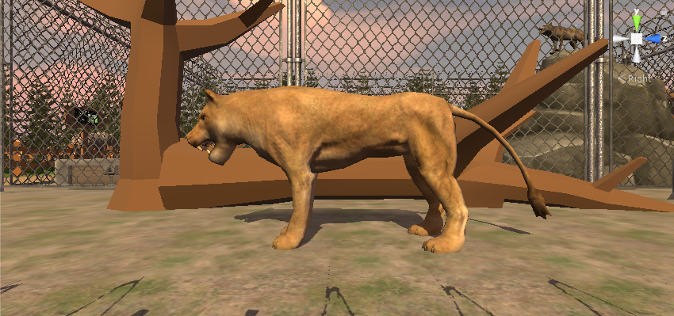

### **The Crocodiles:**

Crocodilians (Crocodylidae) are a family of archosaur sauropsids (reptiles) commonly known as crocodiles. It includes fourteen current species. These are large semiaquatic reptiles that live in the tropical regions of Africa, Asia, America and Australia. They first appeared during the Eocene, about fifty-five million years ago.

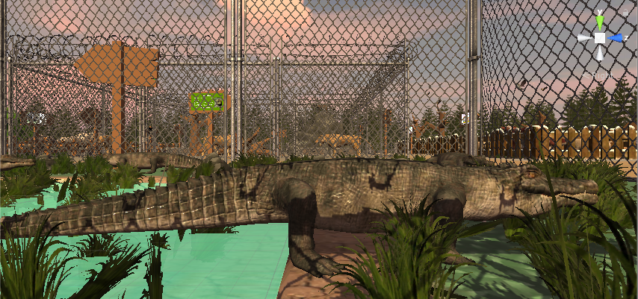

**The Hippos:** it is a semi-aquatic animal that lives in rivers and lakes, and where adult territorial males with groups of 5 to 30 females and young people control an area of the river. During the day they rest in the water or in the mud, and both the copulation and the birth of this animal occur in the water. At dusk they become more active and go out to eat terrestrial herbs. Although hippos rest together in water, grass is a solitary activity, and they are not territorial on land.

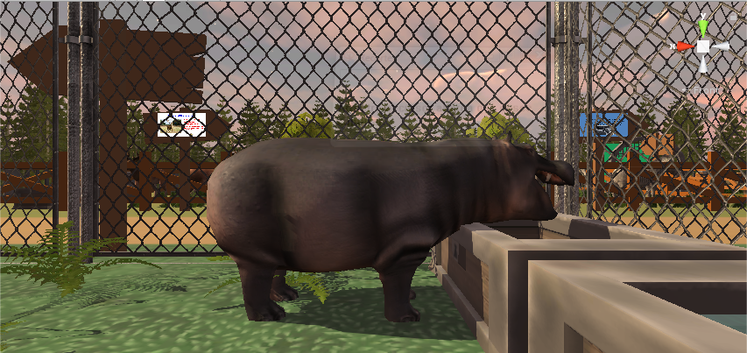

**Fish:** (in Latin pisces) are vertebrate animals primarily aquatic, usually ectothermic (regulate their temperature from the environment) and breathing through gills. They are usually covered by scales, and are endowed with fins, which allow their continuous movement in the aquatic environments, and gills, with which they capture the oxygen dissolved in the water. The Pisces group is not a taxon because it would be paraphyletic. The fish are abundant both in salt water and in fresh water, being able to find species from the mountain streams (for example, the goby), as well as in the depths of the ocean (for example, swallow-eels).

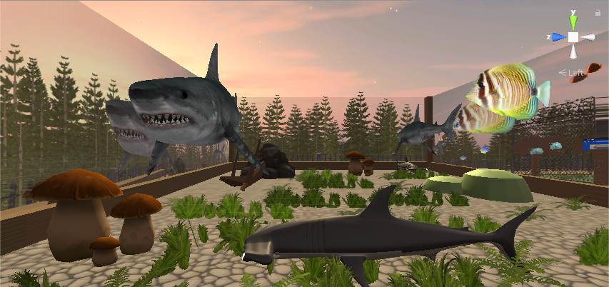

**Birds:** They are vertebrate animals, warm-blooded, that walk, jump or remain alone on the hind limbs, while the forelimbs are modified as wings that, like many other unique anatomical features that allow them, in most of the cases, fly, but not all fly. They have a body covered with feathers, the current birds, and a horny beak without teeth. To reproduce they lay eggs, which hatch until they hatch.

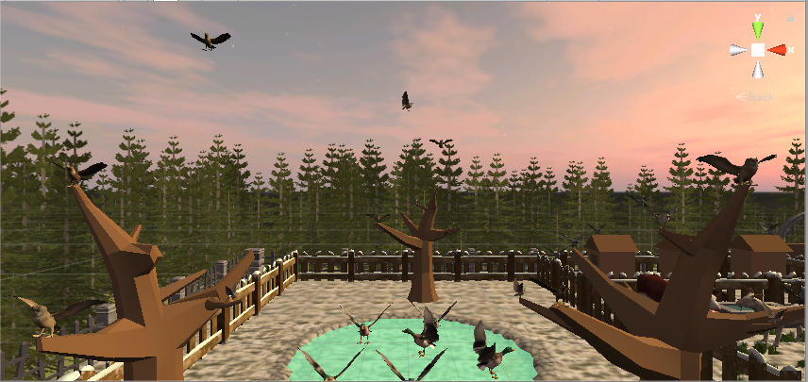

**Farm Animals:** A farm animal is a wild animal that has been domesticated to help its strength at work as the horse or to feed on its meat as in the case of the pig. They are animals that have been domesticated for food or work. In a farm we can also find guardians or guides, such as dogs.

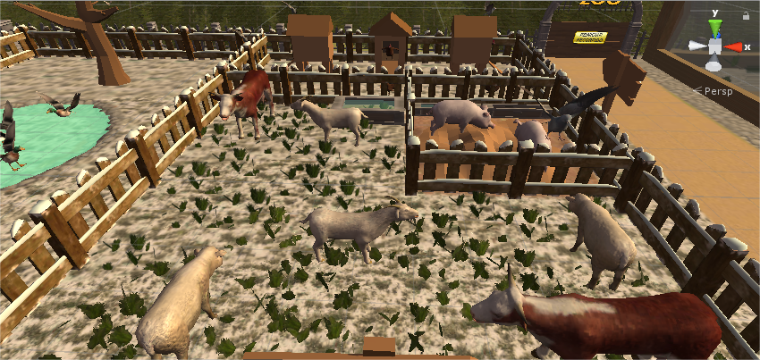

# MUSICAL SCORES AND SOUND EFFECTS

The overall sound of the game should complement the abstract visual style.

## MUSIC AND SOUNDS USED:

[Cool African Music - African Safari](https://www.youtube.com/watch?v=XxlpnNEk6eY).

Sounds that belong to each animal.

# GAME INTERFACE:

SCREEN FLOW DIAGRAM:

